# Wind tube factors coding manual

**The task**

Design task: create an object out of craft materials that hovers in the top half of a tube set over an upwards-facing fan for 10 seconds

Thus, a design can fail in two ways, by flying out the top or falling to the bottom. Designs often bob around in the tube, staying within the acceptable area for a while before flying out or falling. So, if a design does not immediately fail, students start counting to see if they can get to 10 before it fails.

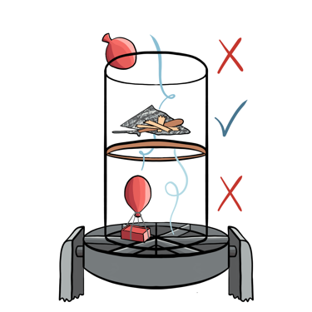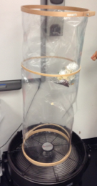 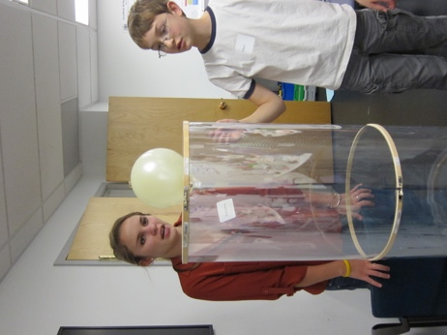

The tube is 14” across and 40” tall. Some students stand on chairs to test their designs more carefully.

**The workshop**

* Single day Saturday workshop at the CEEO (Fall 2013) for grades 4-6
* 13 students (5 girls), some knew each other beforehand (students who wanted to work with friends/relatives did), all were on the CEEO listserv, but I intentionally chose students who hadn’t been to workshops recently or ever
* They worked on 4 tasks, the wind tunnel was the second task, each task was about an hour
* 6 groups, five pairs and one group of 3 (same-gender groups, the group of 3 was girls)

**Coding**

I’m interested in the factors the students attended to while building and testing their designs, such as weight (the 5 factors are in the table on page 4). These factors relate to the design, the test, and/or how the design and test interact. I’m not claiming that any factors are more sophisticated than others, or even that some are more useful than others. But I am claiming that considering multiple different factors and multiple factors simultaneously is more complex. Claims from the coding are qualitative and descriptive—I’m not counting codes at all or comparing groups, but presenting results graphically to show trends over time across groups.

Generally, ideas about factors referred to:

* design ideas (whether or not they’re implemented)
* test results
* proposed or implemented changes to a design

These ideas can also be in the form of advice to other students.

In general, one of the following requirements should be met for a turn to be coded:

* **Design features/modifications have to be linked to a factor**
  + “I added popsicle sticks to make it heavier”
* **References to factors have to be linked to a design’s function or performance (or a test result)**
  + “I need it to go down, so I’m adding weight”

The following “rules” (and examples) give more details on how to apply these requirements.

Basics

* Coding by turn
* Double coding allowed (2 codes for same turn)
* Only student turns coded (not facilitators)

DO code

* Features/changes that need multiple turns to decipher the related factor
* If link to performance is implied
* Incomplete revoicings

DON’T code

* References to design features or materials if factor isn’t clear
* Mentions of factors that don’t relate to design performance

**Only student speech coded**

No facilitator speech is coded, even if a facilitator used speech that would be coded for a student. As an example, a facilitator after a test asked, “Maybe add more weight?” and the student replied, “Yeah.” Nothing in this exchange would be coded.

**DO CODE**

**DO code: If factor or link to performance can be deduced over multiple turns**

The “what” and the “why” or “how” can be given in multiple turns and still be coded. For example,

Student: It needs another parachute.

Facilitator: Why?

Student: So it can hold even more air.

Here, the student turns would be coded as “air pushing/catching air.”

Most often, the codes can be determined based solely on the words in that turn, but sometimes it’s necessary to know what students are working on and previous conversations.

**DO code: If link to performance is implied**

Students often didn’t explicitly mention the test result, presumably because they assumed others witnessed the test. If this seems to be the case, and the design performance seems to be implied, then the turn would be coded. For example, if, as a design flies out of the tube, a student says, “More weight!”, this would be coded (as weight), because it is assumed that they mean: “Because my design just flew out the top, I’m going to add more weight to it, to make it heavier.” Similarly, if this student had said, “Too light”, that would also be coded (as weight), because they are saying that the reason for the test result is the design’s weight. The important thing is that it is clear that they are attending to a factor as relevant for designing and/or interpreting a test result.

**DO code: Revoicings, even if incomplete**

Student: I added another parachute to catch more air

[Tests, falls down]

Facilitator: What do you think?

Student: Another parachute!

Both student turns would be coded (for air pushing/catching air), because it can be assumed that in the second turn (“Another parachute!”) the student is still attending to that factor when they mention another parachute.

Don’t worry too much about how many turns in a single conversation to code due to revoicing or links over multiple turns. Most likely, if coders choose the same code for the same topic in the same exchange, it will be considered agreement in calculating IRR, even if one coder coded more turns than the other.

**DON’T CODE**

**DO NOT code: design features or materials if you cannot identify the factor they are attending to**

Mentions of design features that are not unambiguously linked to a factor are not coded. For example, a student said after a test, “It needs another parachute,” but did not give any explanation for what they meant by parachute, why a parachute would help, or how it would function, so that turn would not be coded. (The issue here is the student may be thinking a parachute would catch air, or make the design more stable, or they may just associate parachutes with flying things, and we don’t know which is the case.) If the student had said, “It needs another parachute to catch more air” then it would be coded as “air pushing/catching air.”

Similarly:

Liam: Oh that's a good idea, cutting it [egg carton] in half, that will probably work

This would not be coded, because while Liam is likely attending to some factor in his appraisal, it is unclear what that factor is (weight? Size? Stability?).

No: I poked holes in the thing

Yes: I poked holes to let air through [coded as air flow]

NOT coded (assuming previous/later turns don’t clarify), because references to materials do not imply weight:

Kerrianne: What did you change from last time?

Regan: I put more tin foil on it

Student: What is wrong with this? I’m adding tons of stuff! [stuff does not imply weight]

Student: But I added a paper clip! [Not clear what they thought the paper clip should have done]

**DO NOT code: references to factors not related to a design’s function or performance**

Regan: [picks up lollipop sticks] Oh these things are heavy

This is attending to a factor, weight, but only as a material property, not a design change or performance.

Student: Look, their design is so big!

The student is attending to size, but there is no clear relationship to a design’s performance. If they said, “That’s too big, I bet it’s gonna fail” that would be coded as size.

**Transcript conventions**

Turns are numbered—only code numbered lines (facilitator lines are numbered but are not coded)

Facilitators: Lija, Riley, Kerrianne, Chelsea

|  |  |
| --- | --- |
| Skipped lines | * Pause in speaking—end of exchange, usually 10+ sec * Change in speaking group composition (e.g., a facilitator comes) * Change in location (to/from testing station) |
| * (grey lines) | * Non-speech, either actions or other notes, like a change in location or a test result * “?” in * areas are notes I’m uncertain of (e.g.: goes to test?) |
| ?? | * Unclear speech (often too quiet) * If in the middle of a turn, then only a word or short phrase is missing * If a whole turn (Abby: ??), then it might be a longer turn but I can’t hear or understand it. Often I could see lips moving but couldn’t hear over the fan or someone else directly responds so I know there was a inaudible turn |
| () or [] | * Notes, actions, clarification of speech * If there is a “?”, then my best guess for speech, like: “did you have a [try it?]” |
| Red text | * (only in pdf) Turns/actions from the testing camera at the testing station |

Factors students attended to during task

|  |  |  |
| --- | --- | --- |
| Code | Description | Example(s) |
| Weight | Weight of materials or the entire design as a reason for design changes or test result.  Not just references to material weight. | Vincenzo: Well like, like, um, I'm just kind of like if it's too light, like I'm adding some popsicle sticks  *NOT: “Oh these things are heavy”* |
| Size | Size of design or parts of a design, related to design performance  Note: does not include size as related to construction, like needing a long piece of tape | R*: This is the first balloon I've see not float. Why do you think your balloon doesn't float?  Sarah: Um, it's not big enough. |
| Air pushing/  Catching air | Air/wind pushing on a design, references to catching air or trapping air in a design. “Air” refers specifically to air coming from the fan—thus, blowing up a balloon would not be trapping air. In contrast to air flow, this code considers air as a single unit or force. | Cecelia: No wait, because this isn't helium so it will just go down and the air will be pushing it up.  Marco: Uh, it's a bag so it's gonna catch air like this and then the weights in there are gonna make it fall [Also coded for weight] |
| Air flow | Air flowing through designs; air can be split up into different streams. In contrast to ‘air pushing/catching air’, ‘air flow’ codes conceive of air as something that moves. | Liam: Too light, but I have an idea. Why don't you try using the scissors to poke a hole so wind goes through it? |
| Other factors | Design or test-related factors mentioned by students that do not fit into any of the above categories. These factors were each only mentioned by one or two groups. | Sophia: Wow that's so weird! Probably because it's not on the center of the thing. [Test result is due to tube not centered on the fan] |

Examples of “other factors” code:

* Shape of design
* Orientation of design (saying design is/isn’t working because it’s upside down)
* Special movement of design during test (spinning, flipping) specifically related to performance
* Location of tube on fan cage
* Air coming out of design during test (air that started in design but then comes out, so not air flow)
* Amount of air in a design (if not explicitly size or catching air during the test)
* Multiple designs being tested at once
* Pieces falling out of/off of design during test, affecting its performance

**Training set**

|  |  |  |
| --- | --- | --- |
| 1 | Because if it's too light it'll just like, make it go [motioning upwards], it'll like the wind will just push it very easily. |  |
| 2 | Just fill a balloon with different amounts of air, more air will make it go up, less air will make it go down and if you get the correct amount of air |  |
| 3 | Yeah, so I'm gonna, I'm gonna like I'm gonna cut it [pause] Hmm. I think we just need to add more weight. With the aluminum, yeah. |  |
| 4 | Also the shape of your balloon affects it. |  |
| 5 | And if that one doesn't work, we can try my idea which is a circle [showing on tin foil]. Which mine is gonna be a circle with a hole in the middle to let the air go through it. And it'll, that's slightly slanted, like a cup. So imagine this [picks up coffee filter] with a hole in the middle of it. So that like it just stays and the wind goes through it [demonstrating with hands]. You know? And it just keeps it hovering like that [demonstrating going up and down]. |  |
| 6 | Riley: What’d you do?  Student: Umm, I made it a bigger balloon?  Riley: Okay, and why’d you make it a bigger balloon?  Student: Uh, because the other just dropped. |  |